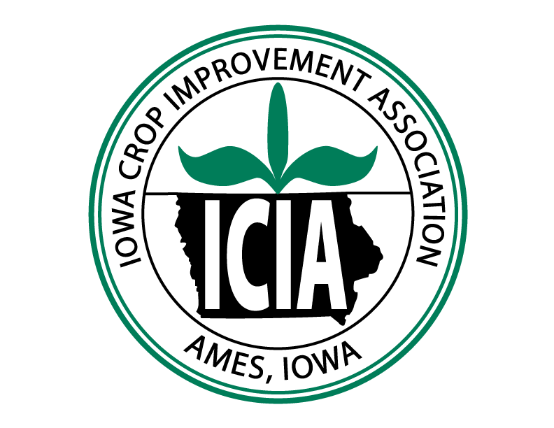**Transfer of Seed Pending Certification**

Iowa Crop Improvement Association

4611 Mortensen Road, Suite 101 Ames, IA 50014-6228

515.294.6921 | www.IowaCrop.org | CertSeed@iastate.edu

**Date of Seed Transfer:**

|  |  |  |  |
| --- | --- | --- | --- |
| **Producer / Seller** | | **Conditioner / Purchaser** | |
| **Company** |  | **Company** |  |
| **Address** |  | **Address** |  |
|  |  |  |  |
|  |  |  |  |
| **Phone** |  | **Phone** |  |
| **Email** |  | **Email** |  |

|  |  |  |  |  |  |
| --- | --- | --- | --- | --- | --- |
| **Lot ID:** | | | **Seed Size (if applicable):** | | |
| **Variety** | **Kind** | **Origin of Seed (State/Country)** | **Class** | **Year Grown** | **Total Shipment Weight** |
|  |  |  |  |  |  |
| **Field No.(s)** | | | | | |
| **Seedstock Lot No.(s) (required for OECD Certification of seed destined for EEC Countries)** | | | | | |

|  |  |
| --- | --- |
| **Stage of Conditioning**    **Comments:** | **Seed Container Type**  **Bulk**  **Work Bags**  **Retail Bags**  **If Bagged: No. of Bags**       **Wt. / Bag**        **Shipped on**       **Number Of Trucks** |

|  |
| --- |
| **PVP Status:**  **U.S. Protected Variety - to be sold by variety name only as a class of certified Seed – 1970 PVPA**  **U.S. Protected Variety - to be sold by variety name only as a class of certified seed – 1994 PVPA**  **U.S. Protected Variety – 1970 PVPA**  **U.S. Protected Variety – 1994 PVPA**  **No U.S. Plant Variety Protection** |
| **Seller’s Declaration**  **I hereby declare that the seed described on this transfer was produced under my name as the applicant for certification and that the fields were inspected by and met the minimum field requirements for certification of the above named Seed Certification Authority.**  **Signed:** **Date:** |

|  |
| --- |
| **Seed Certification Authority Declaration**  **According to certification records the above information appears to be**  **Accurate**  **Inaccurate**    **Transfer Approved**  **Yes**  **No**    **By:**   **Date:** |

The Seed Certification Authority makes no guarantee of the seed documented above, and assumes no responsibility in connection therewith. The original applicant for certification is responsible for delivering seed from fields inspected in such a manner that varietal identity and purity of the seed are maintained.

**Copies will be distributed by the Seed Certification Authority.**